Title

**Voxelization Application**



Centre for Computational Technologies

Transforming human life by democratization of technology

[https://www.cctech.co.in](https://www.cctech.co.in/)







Content Reviewer : Vijay Mali

Revision Date : 22 September 2017

Version : 1.0Revision : 0.0

# Introduction

This document outlines the requirements for the development of an application that converts STL mesh into voxels. The software will provide users with the ability to switch between STL view and voxelized view, along with options to adjust the dimensions of voxels.

## Purpose

The purpose of this software is to provide users with a tool to convert STL mesh into voxels for various applications, including 3D modeling and visualization. By allowing users to adjust voxel dimensions and switch between different views, the software aims to enhance user flexibility and control over the voxelization process.

## Scope

The scope of the software includes the development of a user-friendly interface for importing, converting, and viewing STL mesh as voxels. The application will provide customization options for adjusting voxel dimensions and toggling between STL and voxelized views.

# System Overview

The system will be developed using the following tools:

* C++ programming language for application development.
* Qt framework for GUI development.

# 3 Functional Requirements

1. **Import STL Files:** Allow users to import STL mesh into the software environment.
2. **Convert STL to Voxels:** Provide functionality to convert imported STL mesh into voxels.
3. **Adjust Voxel Dimensions:** Users should be able to adjust the dimensions of voxels according to their preferences.
4. **Switch Views:** Allow users to switch between STL view and voxelized view.
5. **Navigation Controls:** Provide pan, zoom, and rotate functionalities for navigating through the imported models.

# 4 Tools

* C++ programming language for application development
* Qt framework for GUI development
* [Any additional tools or libraries required for the project]

# 5 Milestones and Timeline

| **Sr. No.** | **Milestones** | **Date and Time** |
| --- | --- | --- |
| 1. | Project Problem Statement | 06 May 202404:00 PM IST |
| 2. | SRS Preparation and Initial Presentation | 07 May202412:00 PM IST |
| 3. | SRS Approval | 07 May 202401:30 PM IST |
| 4. | GUI Implementation | 07 May 202407:00 PM IST |
| 5. | Voxelization Tools Development | 08 May 202407:00 PM IST |
| 6. | Real-Time Rendering Integration | 09 May 202407:00 PM IST |
| 7. | Development Time | 11 May 202407:00 PM IST |
| 8. | Finalization and Presentation | 12 May 202404:00 PM IST |

# 

# 6 Conclusion

This software aims to provide users with a versatile tool for converting STL mesh into voxels, offering customization options and intuitive controls for enhanced user experience.

# 7 User Interface

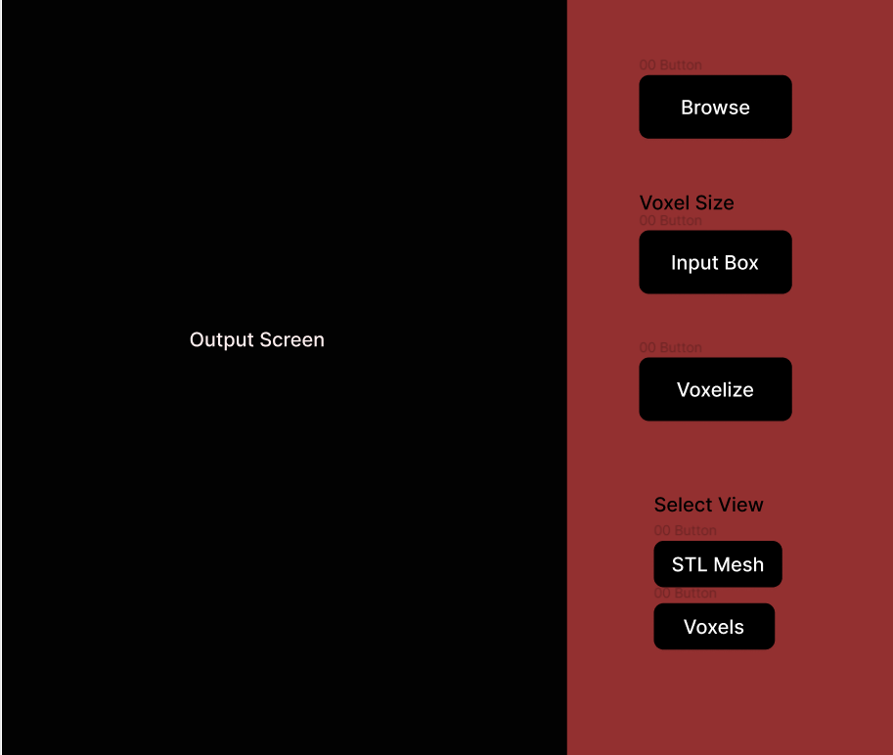

* **Output Screen** - This is the output screen for viewing the output of the stl and voxelized file.
* **Browse** - This button is used for browsing the stl file from the device.
* **Input Box** - This is the input textbox which will take some input for the voxel dimensions
* **Voxelize**- This button will Voxelize the input STL mesh data.
* **STL Mesh and Voxels -** These will be the toggle buttons that will toggle between the STL mesh view and Voexl view.

# 

# 

# 8 Approach

1. Load STL data into the application.
2. Process the information and create the bounding box for the data.
3. According to the size of voxels, create a grid of voxels in the bounding box.
4. Check if the mesh data is residing in the voxels, if not then delete the voxel and if yes then save it to a list.
5. Now give this list to the viewer to visualize.